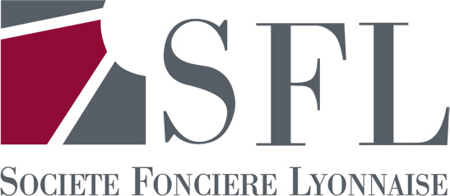
Company Communication
SFL INFLUENCES
Nicolas Reynaud Media contact: Catherine Meddahi
Phone: + 33 (1) 42 97 01 65 Phone: + 33 (1) 44 82 67 07
n.reynaud@fonciere-lyonnaise.com c.meddahi@agence-influences.fr
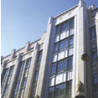




Information on the total number of voting rights as of 31 January 2012
With an exceptional portfolio of properties valued at €3.2 billion including transfer costs, essentially located in the Paris Central Business District, SFL is a preferred vehicle for investors wishing to invest in the Paris office and retail property market. As the leading player in this market, the Group is firmly focused on pro-actively managing high-quality property assets. SFL has elected to be taxed as an SIIC since 2003.

STOCK MARKET:
Euronext Paris Compartment A – Euronext Paris ISIN FR0000033409 – Bloomberg: FLY FP – Reuters: FLYP PA

Paris, 1 March 2012 - In accordance with the provisions concerning voting rights contained in Article L.233-8 II of the French Commercial Code and Article 223-16 of the AMF’s general regulations, SFL discloses the following information:

Date | Number of shares | Number of voting rights
31 January 2012 | 46 528 974 | 46 046 592

